Requirements Document
Project: ARTNEST – Personal Museum Memory & Wishlist
Course: IN-SDE-EN-CMK
Table of Contents
Requirements Document 1
1. Introduction 1
2. Functional Requirements 1
3. Non-Functional Requirements 2
4. Use Cases 2
Use Case UC-01: Register Account 2
Main Success Scenario 3
Extensions 3
Use Case UC-02: Search Artwork 3
Main Success Scenario 3
Extensions 4
Use Case UC-03: Save Artwork 4
Main Success Scenario 4
Extensions 4
Use Case UC-04: View Saved Artworks 4
Main Success Scenario 5
5. Use Case Diagram 5

Introduction
This document describes the requirements for the ARTNEST web application. ARTNEST is a platform designed for people who enjoy visiting museums and galleries. The application allows users to discover artworks, save artworks they want to see in the future, and keep track of artworks they have already seen.
The purpose of this document is to clearly define the functional and non-functional requirements of the system, as well as the use cases that describe how users interact with the application.

Functional Requirements
Functional requirements describe what the system should do and define the core features of the application.
ID | Name | Description | Constraints
FR-01 | User Registration | Users should be able to create an account in the system. | Users must provide a valid email and password.
FR-02 | User Login | Users should be able to log into the system using their credentials. | Authentication is required before accessing personal features.
FR-03 | Search Artworks | Users should be able to search for artworks using keywords such as artist name or artwork title. | Search results should display relevant artworks.
FR-04 | View Artwork Details | Users should be able to view detailed information about an artwork. | Information may include title, artist, museum, and description.
FR-05 | Save Artwork | Users should be able to save artworks to their personal collection or wishlist. | Only logged-in users can save artworks.
FR-06 | View Saved Artworks | Users should be able to view the artworks they have saved in their personal collection. | Saved artworks are linked to the user account.
FR-07 | Remove Saved Artwork | Users should be able to remove artworks from their saved collection. | The system must update the collection after removal.

Non-Functional Requirements
Non-functional requirements describe how the system should perform and define quality attributes of the application.
ID | Name | Description
NFR-01 | Performance | The system should load pages within 2 seconds under normal usage conditions.
NFR-02 | Usability | The interface should be easy to use and intuitive for new users.
NFR-03 | Security | User authentication and personal data must be securely stored and protected.
NFR-04 | Compatibility | The web application should work on modern web browsers such as Chrome, Firefox, and Edge.
NFR-05 | Responsiveness | The interface should adapt to different screen sizes including desktop and mobile devices.

Use Cases

Use Case UC-01: Register Account
Actor: User
Description:
Allows a new user to create an account in the system.
Trigger:
User selects the registration option.
Pre-condition:
User is not logged into the system.
Post-condition:
A new user account is created and stored in the system.

Main Success Scenario
- User navigates to the registration page.
- System displays the registration form.
- User enters email and password.
- User confirms the registration.
- System validates the information.
- System creates a new account.
- System confirms successful registration.

Extensions
3a: Invalid email format
- System displays an error message.
- User must correct the information.

Use Case UC-02: Search Artwork
Actor: User
Description:
Allows the user to search for artworks using keywords.
Trigger:
User enters a keyword in the search field.
Pre-condition:
The system contains artwork information.
Post-condition:
The system displays matching artworks.

Main Success Scenario
- User enters a keyword in the search field.
- User submits the search request.
- System processes the search query.
- System retrieves matching artworks.
- System displays the search results.

Extensions
1a: No artworks found
- System displays a message indicating no results.

Use Case UC-03: Save Artwork
Actor: User
Description:
Allows the user to save an artwork to their personal collection.
Trigger:
User selects the save artwork option.
Pre-condition:
User must be logged into the system.
Post-condition:
The selected artwork is added to the user's collection.

Main Success Scenario
- User searches for an artwork.
- System displays the artwork results.
- User selects an artwork.
- System displays artwork details.
- User clicks the "Save Artwork" button.
- System adds the artwork to the user’s collection.
- System confirms that the artwork has been saved.

Extensions
5a: User is not logged in
- System prompts the user to log in.

Use Case UC-04: View Saved Artworks
Actor: User
Description:
Allows users to view the artworks they have saved.
Trigger:
User opens their personal collection.
Pre-condition:
User must be logged in.
Post-condition:
System displays saved artworks.

Main Success Scenario
- User logs into the system.
- User navigates to their saved artworks.
- System retrieves saved artworks from the database.
- System displays the list of saved artworks.

Use Case Diagram
The Use Case Diagram illustrates the relationship between the user and the system functionalities.
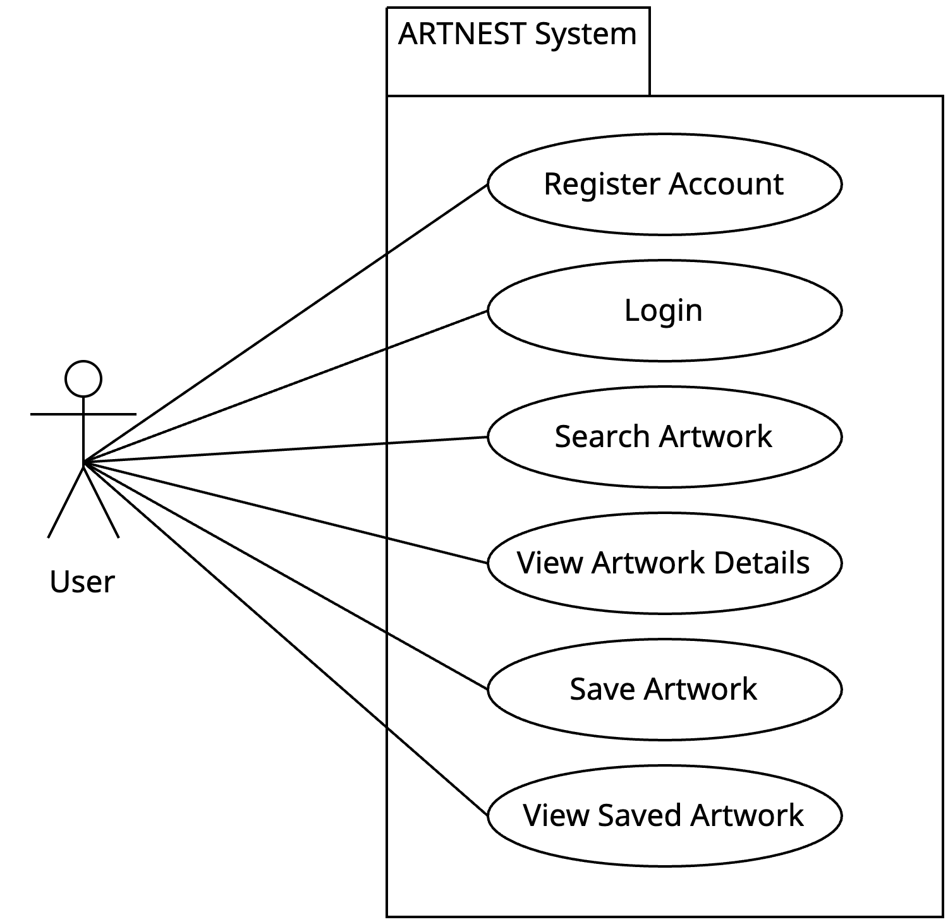

This diagram shows how the user interacts with the main functionalities of the ARTNEST system.

